**Back-end**

1. File Upload enpoints

There is no file upload control to upload the file in Swagger

1. Job, Employee, all endoints:

Job endpoints are singular: Use jobs instead of job in endpoints.

All endpoints have singular resource name instead of plural.

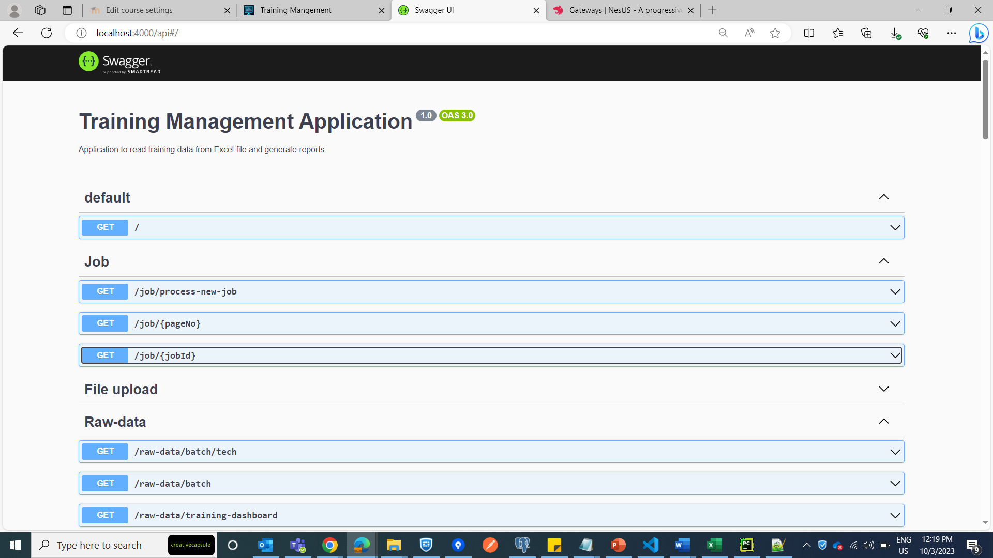

1. Job service

Duplicate messages are written at multiple places.

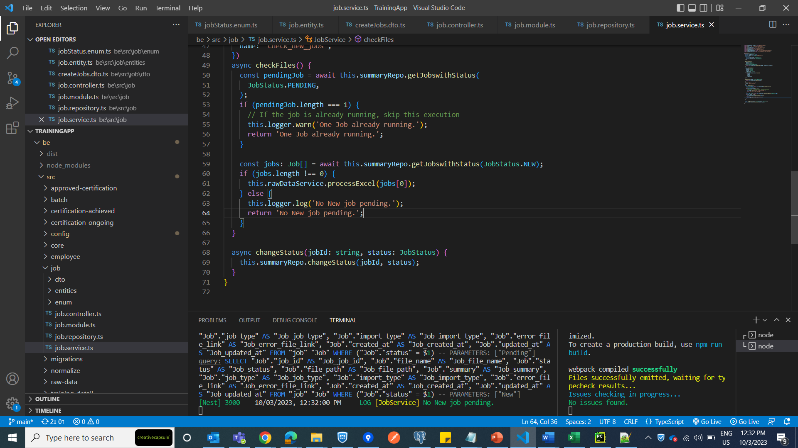

1. Batch repository: Comments are not correct/updated

Ex: Some comments have text ‘Postman’

1. Magic string “asc/desc” in multiple files

Ex: Job.repository.ts - Order: 'ASC’ (line number 62, 92,)

1. Base entities are missing